Data Analysis HW4

# Question 1 Answers

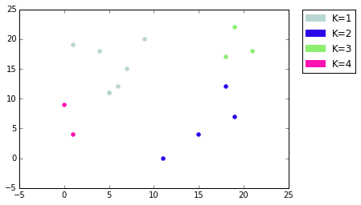 A.) Clustering plot when data points are plotted in order.

s

Cluster Centers:

(Xave, Yave, NumPoints)

{1: (5.2857142857142865, 15.142857142857142, 7),

2: (15.75, 5.75, 4),

3: (19.333333333333332, 19.0, 3),

4: (0.5, 6.5, 2)}

Data point order:

X Y Cluster

0 6 12 1

1 19 7 2

2 15 4 2

3 11 0 3

4 18 12 2

5 9 20 1

6 19 22 2

7 18 17 2

8 5 11 1

9 4 18 1

10 7 15 1

11 21 18 2

12 1 19 4

13 1 4 1

14 0 9 1

15 5 11 1

B.) Clustering plot when data points are plotted in reverse order.

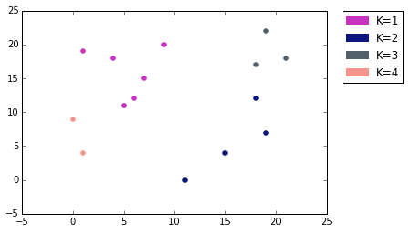

Cluster Centers:

(Xave, Yave, NumPoints)

{1: (4.6250000000000009, 5.375, 8),

2: (18.333333333333336, 16.333333333333332, 6),

3: (11.0, 0.0, 1),

4: (1.0, 19.0, 1)}

Data points order:

X Y Cluster

15 5 11 1

14 0 9 1

13 1 4 1

12 1 19 4

11 21 18 2

10 7 15 1

9 4 18 1

8 5 11 1

7 18 17 2

6 19 22 2

5 9 20 1

4 18 12 2

3 11 0 3

2 15 4 2

1 19 7 2

0 6 12 1

C.) Use Rand index to find the difference between the two clusterings obtained in (a) and (b). Informally, identify the cluster in (a) that has been altered the most in clustering done in (b). Give informal explanation of why this cluster broke apart the most.